Chapter 4

Machine learning-guided high throughput nanoparticle design

4.1 Abstract

Active learning has emerged as a promising strategy to address the data scarcity that hampers molecular machine learning in real-world applications. In this chapter, we implement and evaluate a semi-automated design-make-test workflow that integrates microfluidic formulation, high content imaging, and machine learning to optimize the uptake of PLGA-PEG nanoparticles in MDA-MB-468 breast cancer cells. By iteratively selecting informative experiments using a Bayesian neural network, we demonstrate that active learning can effectively guide formulation decisions in a high-dimensional design space under strict data constraints. Within two five-day experimental cycles, nanoparticle uptake was tripled, and the resulting model could reliably distinguish between low- and high-performing formulations. Model interpretation revealed clear compositional patterns underlying uptake performance, supporting the potential for interpretable, hypothesis-generating models in formulation design. While the experimental system is specific to nanoparticle design, the challenges addressed – limited data, costly labels, and complex search spaces – are shared with molecular machine learning for small molecule discovery. As such, this work provides a controlled, experimentally grounded test case for evaluating active learning strategies and offers insights that are transferable to adjacent fields. This study reinforces the promise of integrating active learning with experimental feedback to accelerate molecular design under real-world constraints.

4.2 Introduction

Molecular machine learning models routinely face the challenges of low-data regimes, especially in the realm of drug discovery. This was again illustrated in the previous chapter where we demonstrated that learning structure-activity relationships becomes increasingly challenging in low-data settings. As a potential solution, active learning has been proposed^{1,2} as a data-efficient learning strategy that iteratively expands a model’s knowledge horizon through experimental feedback (see section 2.5.2). Although several computational studies have explored active learning with small molecules, few studies have successfully implemented design-make-test pipelines³. Despite its promise, integrating automated experimental validation into active learning workflows remains a significant challenge.

To explore the potential of (semi-) automated active learning pipelines when faced with severe data scarcity we used nanoparticles, instead of small molecules, as an illustrative and controlled test case. Nanoparticles – serving as a platform for many biomedical applications⁴, ranging from diagnosis⁵ and disease prevention⁶ to novel therapeutic approaches⁷ – can be engineered using a variety of materials^{8,9}, by tuning nanoparticle composition and formulation variables^{10,11}. These properties, in turn, influence nanoparticle fate and their ability to cross biological barriers^{8,12,13}. This versatility opens opportunities to build custom-tailored carriers⁸ but the resulting combinatorial design space makes formulation optimization a daunting task. As a result, data-driven methods like active machine learning that can efficiently navigate this vast space hold a great promise to revolutionize the current landscape of material discovery.^{14–19} At the same time, nanoparticle design serves as the perfect playground to implement the design-make-test pipelines required for successful active learning campaigns.

To this end, we combined three key technologies: microfluidic formulation, high content imaging, and active machine learning into a semi-automated design-make-test workflow for nanoparticle design (Figure 1).

Microfluidics offers precise control for the rapid, reproducible production of highly monodispersed nanoparticles^{20,21} by handling small volumes of liquids in highly controlled environments. In parallel, advances in automated fluorescence-based microscopy and bio-image analysis tools²² has enabled high throughput screening of nanocarriers using high content imaging (HCI). Here, fluorescence imaging and analysis provides multiparametric quantitative data from images^{23,24} such as nanoparticle uptake^{25,26} or cytotoxicity²⁷. Active machine learning integrates seamlessly with these experimental techniques by iteratively guiding nanoparticle formulation and screening decisions^{28,29}, accelerating design cycles while reducing the number of experiments required^{1,30}. Although these techniques have been widely explored on their own, to the best of our knowledge, they have never been integrated together. Here, we present such a workflow (Fig. 4.1a), applying microfluidic-assisted formulation, high content imaging, and active machine learning to rapidly design PLGA-PEG nanoparticles that are taken up in MDA-MB-468 breast cancer cells, with broad potential for other nanoparticle materials or target variables.

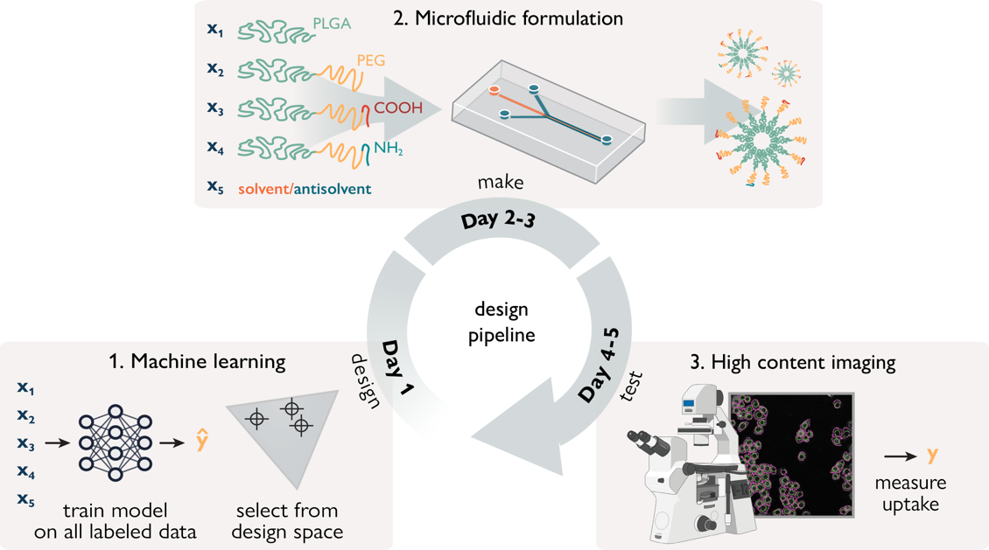 Figure 4.1. Conceptual overview of the proposed nanoparticle design pipeline. The three key integrated technologies: (1) a machine learning model learns the relationship between nanoparticle formulations (x) and their corresponding property (y), and is used to decide on which designs to make, (2) nanoparticles are formulated using microfluidics-assisted nanoprecipitation by controlling different formulation variables x_{i}, (3) the formulations are screened with high content imaging (HCI) to determine their properties y_{i} (e.g., their uptake in MDA-MB-468 cells, as in this proof of concept).

4.3 Nanoparticle design platform

Design cycle
Our proposed workflow is constituted of three components (Fig. 4.1a), based on three technologies, each of which contributes to the complete ‘design-make-test’ cycle:
- A machine learning model $\hat{y}=f\left(x\right)$ is trained on all available labeled data and is then used to suggest which designs to formulate.
- Microfluidics is used to formulate nanoparticles ($x$).
- Nanoparticle properties ($y$) are determined using high content screening.
Each cycle can be performed in a week in a semi-automated fashion, allowing for rapid design iterations. The individual platform components are outlined in detail below.

Design: active machine learning
Active learning is used to choose which nanoparticle designs to formulate based on model predictions³⁷. Models are trained on all available labeled data and used to perform inference on a virtual screening library that resembles the nanoparticle design space (Fig. 4.2a). The chosen design space evenly spans the combinatorial space of the nanoparticle formulation variables. The theoretical design space, given the experimental error of our setup and the characteristics of our case study (see section 4.4 for spoilers), is approximately $1.85 × {10}^{8}$ (see supplementary), however, we deem 100,000 designs sufficient for this proof-of-concept study.

We let models choose the next formulations using two distinct strategies: exploration or exploitation^{1,30}. In exploration, new regions from the design space are investigated. Here, the samples that are expected to be the most informative to learn from (i.e., uncertain predictions) are selected. Exploitation, on the other hand, aims to identify nanoparticles with desired experimental properties in already well-explored areas of the design space (i.e., confident predictions). Based on preliminary experiments (see supplementary figure S4.1) and our modelling requirements, we chose to use a Bayesian neural network³⁸ as our core modeling strategy. Bayesian neural networks enable robust predictions in a low-data setting due to its high expressivity, innate ability to estimate prediction uncertainty, and resilience to dataset shifts³⁹ and overfitting⁴⁰.

Make: microfluidics device
Microfluidic systems have been reported for the rapid and controllable formulation of several self-assembling nanoparticles^{21,31}. Here, we chose a hydrodynamic flow focusing microfluidic device with a Y-junction geometry so we can tune tuning the flow rate ratio between the solvent (S) and anti-solvent (AS)^{32,33}. Fluidic control is achieved using two syringe pumps connected to the middle and side inlets of the Y-junction, for the solvent (S) and anti-solvent (AS) streams, respectively (Fig. 4.2b). Different nanoparticle compositions can be prepared automatically using a syringe pump with a rotary valve connected to the sample reservoirs, containing different building blocks. The mixture is then injected into the middle channel of the microfluidic chip at a constant flow rate, and the anti-solvent rate is adjusted to meet the desired S/AS flow rate ratio. During formulation, the nanoparticles are labeled in situ by encapsulation of a fluorescent dye on their hydrophobic core. This setup enables the automated formulation of nanoparticles with controllable size and composition. Each formulation takes less than 20 minutes, for 1 mg of material (with variable concentration depending on S/AS).

Test: high content imaging
High-content imaging is used to obtain and process widefield fluorescence images in an automated way in 96-well plates (Fig. 4.2c). After imaging, a three-step bio-image analysis pipeline is used, based on CellProfiler³⁴, consisting of (1) nuclear segmentation, (2) membrane segmentation, and (3) intensity quantification (Supplementary Fig. S4.2).

In the case study presented in the following section (see section 4.4), the intensity of the fluorescent dye incapsulated in the nanoparticles is measured to quantify cellular uptake levels. However, many fluorescent-based assays can be adapted to this format, potentially expanding assay capabilities to interrogate cell state³⁵, cytotoxicity²⁷, or nanoparticle fate³⁶.

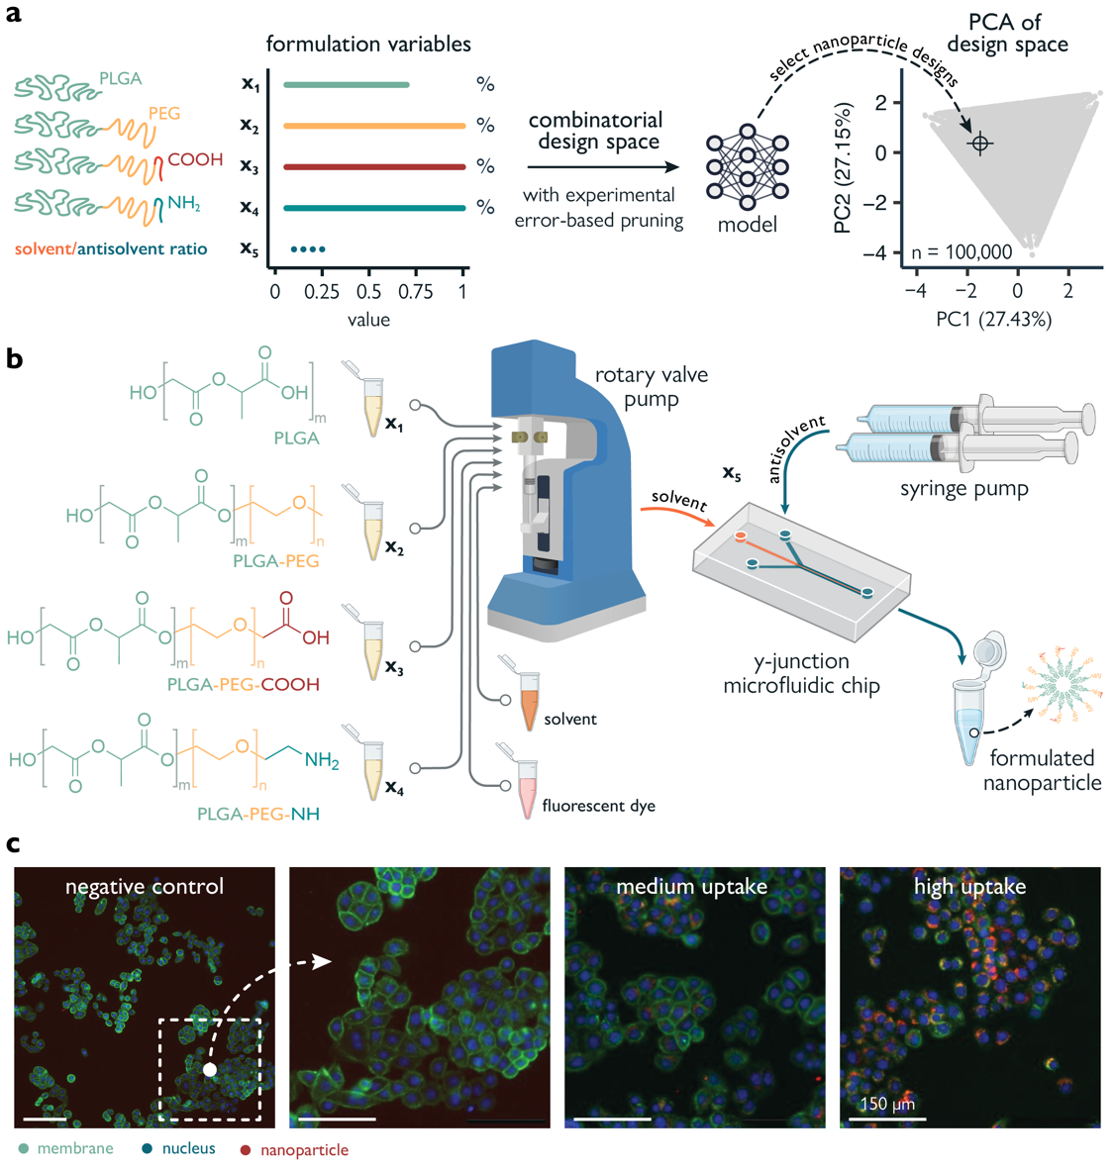
Figure 4.2 | Setup of the design-make-test pipeline. a. Specific nanoparticle designs are selected by a machine learning model from a design space that homogeneously spans the combinatorial range of five nanoparticle formulation variables (x₁₋₅). Designs that would be indistinguishable from each other, based on the experimental error of our setup, were pruned from the design space. b. Formulation of PLGA-PEG nanoparticles by varying four different components (x₁₋₄, PLGA polymers) and one process variable (x₅, solvent/antisolvent flow rate ratio). Polymer components are mixed with a rotary valve pump and injected into the middle channel of a hydrodynamic flow focusing (HFF) device. Different ratios of solvent/antisolvent are accomplished by changing the antisolvent (water) flow rate with a syringe pump. c. For imaging of nanoparticle uptake in MDA-468, the raw data is composed of three channels (nuclei, membrane, nanoparticle), each with a field of view of 804x804 px, 1.123 µm/px. Examples qualitatively illustrate three levels of uptake: negative control (no nanoparticles), medium (F8), high (F11).

4.4 Results

Designing PLGA-PEG nanoparticles for high uptake
As a case study, we applied our semi-automated platform to design PLGA-PEG nanoparticles. PLGA-PEG is an amphiphilic block copolymer that self-assembles into nanospheres via nanoprecipitation. This type of formulation can be easily adapted to the microfluidic format^{11,32,33}. In addition, PLGA-PEG has excellent biocompatibility and high tunability. The base polymer can be functionalized with different end-groups, eliciting different properties. We chose to vary four different building blocks (PLGA, PLGA-PEG, PLGA-PEG-COOH, PLGA-PEG-NH₂) and one process variable (the flow rate ratio between solvent and antisolvent). By varying these building blocks that directly influence physicochemical properties (size, PEGylation, and charge), we aim to design nanoparticles with high uptake in MDA-MB-468 cells – a model of human breast cancer. To be specific, hydrophobic fluorescent dyes (DiD) were incorporated into the polymer mixture, after which high content imaging was used to quantify their accumulation (uptake) in cells, expressed as fold-increase over a control (a 100% PLGA-PEG nanoparticle formulated by bulk nanoprecipitation). As auxiliary physicochemical characterization, size (hydrodynamic diameter, nm) and polydispersity index (PDI, µm) was measured for each formulated nanoparticle in addition to cellular uptake.

The proposed design platform was used to perform three cycles. Per cycle, selected nanoparticles formulations were produced with their desired composition parameters ($x$) and the measured uptake ($y$) per nanoparticle was used to train a Bayesian neural network $p\left(y|x\right)$. The trained model was then used to select the next cycle formulations from a virtual library of 100,000 nanoparticles that homogenously span the entire design space. As a quality filter, formulations from this virtual library were only considered if their predicted PDI was lower than 0.2, which we consider to be an upper limit of acceptable monodispersity for biomedical applications such drug delivery. PDI was predicted with a different machine learning model (XGBoost, see Materials and Methods) that was trained and updated alongside the main Bayesian neural network.

Cycle 0 (inception)
Machine learning models need training data to start with. When the dataset is limited by size, it has been shown that models can benefit from starting with a diverse dataset⁴¹. We selected 28 nanoparticle formulations (cycle 0) that were distributed homogeneously within the design space (Fig. 4.3a) using Design of Experiments (see Material and Methods). This yielded a starting set with diverse compositions⁴² (Fig. 4.3f). Next, the 28 nanoparticle formulations were produced, and the cellular uptake of the resulting nanoparticles were quantified.

Nanoparticle uptake in MDA-MB-468 cells ranged from 0.40 to 4.77-fold with respect to the uptake standard, with an average uptake of 2.03 ± 1.28-fold (Fig. 4.3d, e, dark blue color). The corresponding physicochemical properties (size and PDI) are available in Supplementary Figure S3 and Table S2. Finally, these experimentally determined uptake values ($y$), together with the nanoparticle’s corresponding formulation variables ($x$), were used to train the first Bayesian neural network $p\left(y|x\right)$.

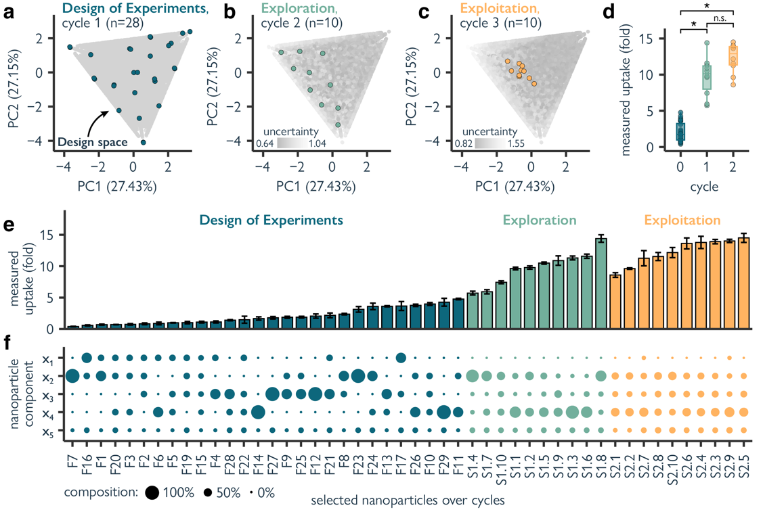
Figure 4.3 | Optimizing PLGA-PEG nanoparticle uptake in MDA 468 cells with machine learning guided formulation. a. Principal component analysis (PCA) of the nanoparticle (NP) design space, projecting the range of all five formulation variables into two dimensions. Each point represents a nanoparticle formulation, with grey representing all formulations of the in-silico screening library (n=100,000), and blue representing formulated nanoparticles in cycle 0 (Design of Experiments, n=28). b. PCA illustrating the selection of nanoparticle formulations for cycle 1 (exploration, n=10). c. PCA illustrating the selection of nanoparticle formulations for cycle 2 (exploitation, n=10). d. Boxplots of the measured uptake of formulated nanoparticles over cycles. Statistically significant differences (p < 0.05) are denoted as *, determined by unpaired, two-sided, Wilcoxon signed-rank tests. e. Measured uptake over screening cycles. Error bars represent standard deviation. Nanoparticles are sorted by uptake for illustrative purposes. f. Composition of the formulated nanoparticles. Circle size represents the percentage of each nanoparticle formulation component. Components used are: x₁; pure PLGA, x₂; PLGA-PEG, x₃; PLGA-PEG-COOH, x₄; PLGA-PEG-NH₂, and x₅; solvent/antisolvent ratio.

Cycle 1 (exploration)
Predictions from the neural network trained with cycle 0 data were used to guide the next design cycle. Here, we primarily aimed at exploring the ‘poorly understood’ regions of the design space. With the goal of increasing overall model performance, we used the model’s prediction uncertainty to drive formulation selection. Since highly similar formulation parameters are likely to yield highly similar results, we enforced a degree of composition diversity to prevent the acquisition of redundant information. We selected ten formulations that were: (a) as diverse from each other as possible (determined via clustering, see Materials and Methods), and (b) with a high prediction uncertainty and moderately high predicted uptake (Fig. 4.3b).

The resulting nanoparticle designs were experimentally assessed and were found to have an uptake in MDA-MB-468 cells ranging from 5.72 to 14.40-fold, with an average of 9.72 ± 2.70-fold. This is a considerable leap in uptake compared to cycle 0 where the best nanoparticle exhibited a 4.77-fold uptake (Fig. 4.3d-e, p < 0.001, unpaired, two-sided, Wilcoxon signed-rank tests). The newly obtained data was combined with the data from cycle 0 and used to re-train the model to guide the next cycle of nanoparticle designs.

Cycle 2 (exploitation)
Having explored the most uncertain areas of the design space, we aimed at obtaining high uptake nanoparticles by selecting formulations in an exploitative manner. Instead of gathering more knowledge about the uncertain areas in the design space, we acquired ten nanoparticle formulations from the virtual screening library that have high predicted uptake and a low prediction uncertainty (Fig. 4.3c). Again, we enforce some degree of diversity among the selected formulations to prevent redundancy (see Materials and Methods).

The designed nanoparticles were found to have an uptake between 8.60 and 14.50-fold, with an average of 12.30 ± 2.02-fold (Fig 4.3d, e). This cycle yielded an improvement in the average uptake over all ten nanoparticles (although not statistically significant over cycle 1, p=0.052, unpaired, two-sided, Wilcoxon signed-rank tests), and to a slightly higher maximum uptake of 14.50-fold.

Starting with 29 rationally designed nanoparticles, cellular uptake in breast cancer cells of was increased from 2.03 ± 1.28-fold to 12.30 ± 2.02-fold in the last of two active machine learning cycles, each proposing ten new designs.

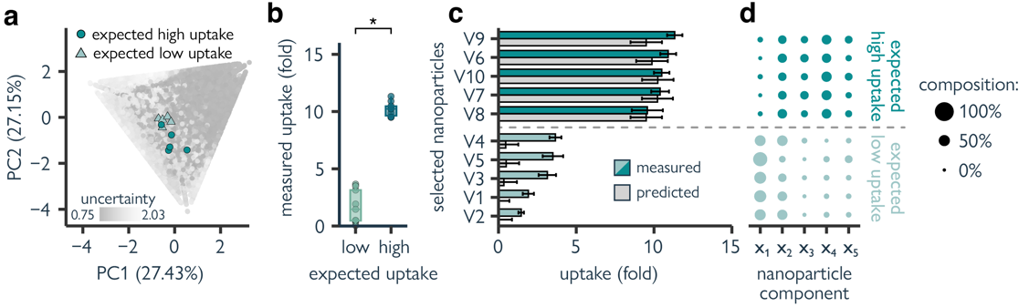
Figure 4.4 | PLGA-PEG nanoparticle uptake in MDA 468 cells for nanoparticles with low predicted uptake and high predicted uptake. a. Principal component analysis (PCA) representing all nanoparticle (NP) formulations of the in-silico screening library (grey, n=100,000), the selected low-uptake formulations (light blue triangles, n=5), and the selected high-uptake formulations (dark blue circles, n=5). b. Boxplots of the measured uptake of formulated nanoparticles with low or high expected uptake. Statistically significant differences (p < 0.05) are denoted as *, determined by unpaired, two-sided, Wilcoxon signed-rank tests. c. Comparison between predicted (grey) and measured uptake for nanoparticles with low- and high predicted uptake. Error bars represent standard deviation. d. Composition of the formulated nanoparticles. Circle size represents the percentage of each nanoparticle formulation component. Components used are: 1; pure PLGA, 2; PLGA-PEG, 3; PLGA-PEG-COOH, 4; PLGA-PEG-NH₂, and 5; solvent/antisolvent ratio.

Model interpretation

To evaluate the quality of the learned composition-function relationships, we applied our model to further interrogate the nanoparticle design space. We retrained the neural network with all data generated from all cycles put together and used it to select five nanoparticles with low predicted uptake and five with high predicted uptake from the virtual screening library for further formulation and screening (Fig. 4.4a).

Although the model was better attuned to high-uptake formulations, it was able to identify both high-uptake (10.54 ± 0.66-fold) and low-uptake nanoparticles (2.74 ± 0.99-fold), with statistically significant differences (Fig. 4.4b-c, p < 0.001, unpaired, two-sided, Wilcoxon signed-rank tests). The ability to differentiate between low and high uptake nanoparticles indicates that the model has learnt relevant formulation-uptake relationships.

In an attempt to rationalize these results, we noted that low- and high-uptake nanoparticles showed statistically significant differences (p < 0.001, unpaired, two-sided, Wilcoxon signed-rank tests) in the content of three polymers (Fig. 4.4d):
- PLGA: low-uptake: 53 ± 9%, high-uptake: 5 ± 5%.
- PLGA-PEG-COOH: low-uptake: 3 ± 5%, high-uptake: 24.4 ± 4.8%.
- PLGA-PEG-NH₂: low-uptake: 10 ± 6%, high-uptake: 25 ± 5%.
This is also reflected in the predictions over the whole design space (see Supplementary Figure S5). Furthermore, low-uptake nanoparticles were found to be more monodisperse (PDI = 0.059 ± 0.013) and bigger (size = 154.5 ± 21.4 nm) than high-uptake nanoparticles (PDI = 0.122 ± 0.015, size = 114.0 ± 5.2 nm). Polydispersity (i.e., nanoparticle heterogeneity) is traditionally considered undesirable. However, this intrinsic heterogeneity could perhaps be considered a structural parameter contributing to nanoparticle fate and biological function⁴³.

4.5 Discussion

In this chapter, we developed a semi-automated nanoparticle design platform that integrates microfluidic formulation, high content imaging, and machine learning within an active learning framework. Applied to PLGA-PEG nanoparticles, our approach iteratively guided nanoparticle formulation toward enhanced uptake in MDA-MB-468 breast cancer cells. Over the course of just two active learning cycles, uptake was tripled, and the model demonstrated the capacity to differentiate between low- and high-performing formulations, offering interpretable insights into composition–function relationships.

The structured and controllable nature nanoparticle formulation allowed us to probe practical questions about how to select informative experiments, perform exploration and exploitation, and build robust models under data constraints. Specifically, the core challenges addressed here – data scarcity, costly experimental feedback, and the need to navigate complex, high-dimensional design spaces – are directly shared with molecular machine learning. By demonstrating that meaningful optimization is possible in an extreme data-limited, experimentally grounded pipeline, this work contributes to a growing body of evidence supporting the feasibility of active learning for molecular discovery – whether for nanomedicine or small molecule drugs.

4.6 Materials and Methods

Nanoparticle formulation

Chemicals. All Poly Lactic-co-Glycol Acid (PLGA)-Polyethylene Glycol (-PEG) based polymers were purchased from Akina Inc. division PolySciTech (West Lafayette, USA): PLGA (#AP082), PLGA-PEG (#AK102), PLGA-PEG-COOH (#AI078), PLGA-PEG-NH₂ (#CAI189). The encapsulated dye was a DiD solution from Invitrogen VybrantTM Multicolor Cell-Labelling kit (Cat no. V22889), purchased from Fisher Scientific (Landsmeer, Netherlands). High-grade acetonitrile (>99%) was used as organic solvent.

Microfluidic chip manufacturing. The microfluidic chips were manufactured in polydimethylsiloxane (PDMS) from a SU-8 patterned Silicon wafer master mold. The design of the corresponding microstructures (a Y-junction, with 200 µm of channel width and 60 µm height) and their manufacturing process are described in detail in our previous work, by Glinkowska et al.³³. Each chip (or PDMS replica) was prepared from the master mold by standard soft lithography. First, a PDMS base polymer and elastomer from a two-component kit (Sylgard 184, Dow Corning) were thoroughly mixed in 10:1 wt:wt ratio. The mixture was degassed in a desiccator, poured over the master mold, degassed once more and baked overnight at 60°C. After elastomer curation, the PMDS chips were peeled off from the master mold, the inlets and outlets were punched with a 1.2 mm biopsy puncher and stored in a dust-free environment. On the same day of formulation, to keep surface hydrophilicity, the PDMS replica was freshly bonded to a clean 25x75 mm glass slide using oxygen plasma (at 20 W for 30s), achieved with an Emitech K1050X Plasma Asher from Quorum (East Sussex, UK).

Microfluidic-assisted nanoparticle formulation. Nanoparticles were formulated by microfluidic-assisted nanoprecipitation, in which an acetonitrile stream (solvent, S) containing all polymer components is hydrodynamically focused by an aqueous phase (anti-solvent, AS) in a Y-junction. The AS phase was ultra-pure water pumped into the lateral inlets of the chip by a Fusion 200 Two-channel Chemyx Syringe Pump (Stafford, USA), while the acetonitrile was pumped inside the central channel by a LSPOnePump with a 10-port valve and a 250-μl syringe from Advanced MicroFluidics SA (Ecublens, Switzerland). This last pump was also used to make mixtures of polymer components prior injection of the organic phase into the device. This was achieved by using the following port configuration: 1 waste, 2 output, 3 mixing, 4 buffer, and the remaining ports (5-9) for dye and polymer components reservoirs. Schematics and port configuration shown in Sup. Figure 5. All solvents used were filtered with a Whatman's polyvinylidene fluoride (PVDF) 0.2 μm membrane filter. Filtered acetonitrile was used to make the polymer stocks (reservoirs) at a concentration of 15 mg/ml and to dilute the commercial DiD dye from 1 mM to 500 μM. The polymer component mix was injected at a total polymer concentration of 10 mg/ml, with an S flow rate of 15 μl/min, and a variable AS flow rate, depending on the desired S/AS ratio (S/AS values ranging from 0.1 to 0.25). DiD was added into the polymer mix at a concentration of 50 μM, to label the particles fluorescently, by in situ encapsulation of the hydrophobic dye into the core of the nanoparticles during the process of nanoprecipitation. For each formulation, 0.5 mg of material was collected (for example, for 0.1 S/AS: 0.5 ml of 1 mg/ml nanoparticle). The nanoparticle solutions were diluted to a concentration of 1 mg/ml and the nanoparticle solutions were left on the shaker at room temperature overnight to allow evaporation of acetonitrile. All tubing (REF: BL-1815-04 & BL-PTFE-1602-20), fluidic connections (REF: CIL_XP-245X) and PDMS couplers (REF: PN-STN-20G-20) were purchased from Darwin Microfluidics (Paris, France). The Chemyx pump was actuated manually, using the touch screen, while the LSPOne pump was actuated using a custom-made MATLAB script.

Bulk formulation of uptake standard. Nanoparticle uptake standard was formulated by bulk nanoprecipitation. A polymer mixture of 10 mg/ml containing PLGA-PEG and 50 μM of DiD in pure acetonitrile was added dropwise to ultra-pure water, in a ratio of 1:10, at room temperature under stirring (700 rpm). The resulting nanoparticle solution (1 mg/ml) was left under stirring (400 rpm) on the plate overnight at room temperature, protected from light, to let the acetonitrile evaporate.

Nanoparticle characterization

Bulk Physicochemical characterization. Polydispersity index (PDI) and hydrodynamic diameter were determined by Dynamic Light Scattering (DLS) using a Zetasizer Nano-ZS (Malvern Panalytical), with a 633 nm laser and 173° Backscatter detector. Bulk fluorescence spectrum (Ex. 605 nm, Em. 646-700nm, 5 nm step) was recorded for each nanoparticle batch using a BioTek Synergy H1 microplate reader (Agilent), in a black-well 96-well plate. nanoparticle solutions were diluted in ultra-pure water (1:10) before measurement. Nanoparticle uptake standard was always included on the plate. Fluorescence coefficients to correct for differences in fluorescence intensity were calculated for each batch in comparison to the uptake standard.

Cell culturing and nanoparticle in vitro screening. Breast cancer epithelial cells MDA-MB-468 (HTB-132) were obtained from American Tissue Culture Collection (ATCC) and cultured under standard conditions (37°C, 5% CO₂) in Dulbecco's Modified Eagle Medium (DMEM) supplemented with 10% FBS (Fetal Bovine Serum) and 1% penicillin-streptavidin. Standard culture reagents (DMEM, FBS, pen-strep, DPBS 1x, EDTA-trypsin), nuclear (Hoechst 33342, Cat no. 62249) and membrane (Alexa FluorTM 488 -Wheat germ agglutinin (WGA) Conjugate, Cat no. W11261) stains, 16% methanol-free paraformaldehyde (PFA) (Cat no. 043368.9M) and human serum (MP BiomedicalsTM Serum, Type AB, Cat no. 11425055) were purchased from Fisher Scientific.

Cells were seeded at a density of 25,000 cells/cm² in an “ibiTreat” μ-Plate 96 well back (Cat no. 89626) from IBIDI (Gräfelfing, Germany), cultured for 38-48h before nanoparticle treatment. Half an hour before starting the treatment, nanoparticle stock solutions were pre-incubated with human serum (1:1, v:v) for 30 min at 37°C. Cells were washed three times with serum-free phenol-free DMEM media, and each nanoparticle condition (pre-incubated with serum) was added to each well at a working concentration of 50 µg/ml. The resulting “incubation media” contained 5% human serum. After 23.5 h, the cells were counterstained with Hoechst and Alexa FluorTM 488 WGA at 37°C. After 24h, cells were washed with serum-free media 3 times, fixed with PFA 2% (diluted in DPBS 1x), for 10 min, at room temperature. After fixation, cells were washed three times with DPBS 1x and stored at 4°C protected from light until imaging.

High content imaging (HCI). Widefield fluorescence imaging was performed using a Nikon Eclipse Ti2 microscope, equipped with and automated focus system, an automated piezo stage, a 25-mm primΣ 95B sMOS camera from Teledyne photometrics (Arizona, USA) and a Spectra X light engine from Lumencor (Oregon, USA). The microscope was operated using Nikon Instrument Software (NIS) elements (v. 5.21.03). Pipeline for automated imaging of well-plates were set using Nikon's High-content dedicated macro (JOBS). For each condition, 10 Field of view (FOV), 16-bit images of 804x804 px (1.123 µm/px) in three channels (nuclei, membrane, nanoparticle), were recorded, using a 20x objective. The optical configuration was as follows: (1) for nuclei, laser excitation at 387 nm, DAPI filter cube (Ex: 379-450, Em: 414-480), 5% laser power, 10 ms; (2) for membrane, laser excitation at 470 nm, with a FITC filter cube (Ex: 461-488 – Em: 503-548), 20% laser power, 75 ms; (3) for nanoparticle, laser excitation at 628 nm, with Cy5 filter cube (Ex: 509-645, Em: 659-736), 40% laser power, 200 ms. To account for variability between days (including possible small variations on laser intensity), the same particle (uptake standard) was always included in the plate. Measurements were taken at room temperature.

HCI post-processing. Microscopy images (16-bit greyscale, 3 channels, .tiff) were batch processed using CellProfiler³⁴(CP), version 4.2.1. The CP pipeline included segmentation of the cells and quantification of fluorescence signal from the nanoparticle channel. For this, nuclei segmentation (‘IdentifyPrimaryObjects’ module), followed by membrane segmentation (‘IdentifySecondaryObjects’ module) and cell identification (‘IdentifyTertiaryObjects’ module) was performed. Following segmentation, the ‘MeasureObjectIntensity’ module was used to compute the mean fluorescent signal per cell per unit of area; and the ‘MeasureImageQuality’ module was also used for quality control checks. The data was exported in .csv files, per single object (nuclei, cytoplasm, cell) and per image. MATLAB was used to calculate means and standard deviations of the features of interest.

Machine learning and computation

Design of experiments (DoE). The starting dataset (initial formulation runs, cycle 0) of PLGA-PEG nanoparticles was proposed using design of experiments (DoE), with Statgraphics Centurion 19. An augmented simplex lattice mixture design was created with one response variable (Uptake in MDA-468 cells), one process variable (S/AS with two levels), and 4 components (PLGA, PLGA-PEG, PLGA-PEG-COOH, PLGA-PEG-NH₂). In mixture designs, all components need to sum up to one (100% of the mixture) and can take up values from zero to one, unless stated otherwise. Process variables are discrete values. A linear model was selected for the process variable and a special cubic model for the mixtures, resulting in a design with 28 coefficients. Using the backward selection exchange algorithm implemented in the software, the number of runs was then set to 31. As a rule of thumb, the minimum number of runs to fit a model in DoE is the number of coefficients +3. Two runs were manually removed from the resulting dataset (100% PLGA, at 0.1 and 0.25 S/AS) since pure PLGA nanoparticles cannot form without the addition of any surfactant, and one run (F15) was manually added. The resulting list of initial formulations, including their physicochemical characterization is available in Sup. Table 2.

Nanoparticle uptake prediction. A Bayesian neural network was used, denoted as $p_{θ}\left(y | x\right)$, to predict nanoparticle uptake ($y$) from nanoparticle formulation ($x$). The model parameters $θ$ were initiated as probability distributions with Gaussian priors. To approximate the posterior distribution, stochastic variational inference (SVI) was used. Following the standard SVI approach⁴⁴ (see section 2.4.9), a simpler guide model $q_{θ}(x)$ was deployed that uses a multivariate normal distribution to approximate the true posterior distribution of $p_{θ}$. The model consisted of three hidden layers with ReLU activation functions. The model was trained with the ADAM optimizer⁴⁵, to maximize the evidence lower bound (ELBO). The ELBO is calculated as follows (Eq. 1):

$$\text{ELBO}=E_{q_{θ}(θ)}\left[\log{p_{θ}\left(y\right|x, θ)}\right]-\text{KL}(q_{θ}(θ) |\left|{ p}_{θ}\left(θ\right)\right), (1)$$

where $z$ represents the latent variables that aim to capture the data’s structure, and $KL$ is the Kullback-Leibler divergence⁴⁶ between the guide distribution and the true posterior distribution. To estimate the prediction uncertainty, the predictive distribution was constructed by taking 500 Monte Carlo samples for each data point. Nanoparticles with a PDI greater than 0.2 were excluded for training the uptake prediction models.
Size and PDI prediction. Nanoparticle polydispersity index (PDI) and size (hydrodynamic diameter) predictions were performed with an Extreme Gradient Boosting⁴⁷ (XGBoost) model, which is based on decision trees. These models were trained on all available data for each design cycle. PDI and size values were log-transformed.

Model evaluation. Due to the low data setting, all available data was used to train the models in each cycle. Five-fold cross-validation⁴¹ using 80/20 train/test splits was applied to ensure model robustness and stability. The model performance with cross-validation was computed via the root mean squared error (RMSE), calculated as follows (Eq. 2):

$$RMSE=\sqrt{\frac{\sum_{i=1}^{n}{{\left({\hat{y}}_{i}-y_{i}\right)}^{2}}}{n}}$$ | (2)

where $\hat{y_{i}}$ is the predicted value for the i-th nanoparticle (when it is not used to train the model) and $y_{i}$ is its ‘true’ experimentally measured value (uptake, PDI, or size). To reduce the stochastic influence of random splitting, five-fold cross-validation is performed a total of three times with different random splits. Finally, the estimated model performance was calculated by taking the average RMSE over all splits.

Model training and optimization. Model hyper-parameters were optimized with cross-validation at each screening cycle, by choosing those leading to the lowest RMSE (Eq. 2). For Bayesian neural network models, we optimized the learning rate (values: 1x10⁻³, 1x10⁻⁴, 1x10⁻⁵) and the number of neurons per hidden layer (16, 32, 64) using a grid search. For XGBoost models, Bayesian optimization was used to choose among 500 sets of hyperparameters. The specific sets of hyperparameters to try were selected by maximizing the expected improvement of a Gaussian Process estimator. The following hyperparameters were optimized: learning rate/eta = [0 – 1], maximal tree depth = [2 – 20], minimal child weight = [1 – 20], minimal loss split $γ$ = [0 – 20], number of trees = [50 – 500], subsample ratio = [0.1 – 1], column subsample ratio by tree = [0.1 – 1], L2 regularization $λ$ = [0 – 10], L1 regularization $α$ = [1 – 10]. For random forest models, the same hyperparameter optimization was used using the following hyperparameters: number of trees = [50 – 500], maximal tree depth = [10 – 50], and minimal samples per split = [2 – 10]. Gaussian process models were optimized using a grid search. The following hyperparameters were optimized: regularization parameter $α$ (values: 10⁻³, 10⁻², 10⁻¹, 1) and the kernel (Radial Basis Function, length scale = 1 within the range [10⁻² – 10²]; Matern kernel, length scale = 1 within the range [10⁻² – 10²], smoothness = 1.5; Rational Quadratic Kernel, length scale = 1 within the range [10⁻² – 10²], $α$ = 1; Exponential Sine Squared Kernel, length scale = 1 within the range [10⁻² – 10²], periodicity = 3 within the range [10⁻² – 10]; Dot Product Kernel, σ = 1 within the range [10⁻² – 10]). All kernels used a constant kernel multiplier bounded within the range [10⁻³ – 10³].

Experimental error calculation. The experimental error of the nanoparticle formulation was computed by considering the balance error (± 0.01 mg), the volume-dependent systematic and random pipetting error (see Sup. Table 7), and a pump maximum dispensing error (1%). These values were taken from their corresponding manuals. The errors were considered as additive and independent and were calculated as the quadrature of the individual errors. The estimated errors were: 1.25% (PLGA), 1.21% (PP-L), 1.24% (PP-COOH), and 1.24% (PP-NH₂). Possible errors or variations in the flow rates of the solvent or antisolvent were not considered for this calculation, neither were errors introduced by dead volumes or by the carryover volume of the valve in the LSPOne pump.

Data augmentation based on experimental error. To artificially inflate the training data and simultaneously incorporate a notion of measurement error into the model, all training data was augmented 5 times (1x the original data + 4x augmented data), resulting in a slight increase in performance in preliminary experiments. Data augmentation was applied throughout cross-validation and model fitting. For each nanoparticle, PLGA, PLGA-PEG, PLGA-PEG-COOH, and PLGA-PEG-NH₂ values were multiplied with random samples from a normal distribution parameterized by their corresponding experimental error, as determined above. Similarly, nanoparticle uptake, PDI, and size were augmented using the standard deviation of the respective measurements.

Virtual screening library. A virtual library of nanoparticle formulations was generated to span the design space, by sampling PLGA, PLGA-PEG, PLGA-PEG-COOH, and PLGA-PEG-NH₂ composition ratios from a Dirichlet distribution (all variables range from zero to one, adding up to one). We considered sampled variables with values lower than 6% as 0%, taking the carryover error of the pump into account. These discarded values were added to another non-zero variable at random to enforce that all ratios still add up to one. Nanoparticle formulations that overlapped in experimental error or had a PLGA ratio higher than 0.7 were discarded. Finally, solvent/antisolvent ratios of [0.10, 0.15, 0.20, and 0.25] were sampled from a uniform distribution for each virtual nanoparticle. For practical reasons, a total of 100,000 virtual formulations were sampled from of the 1.85 x 10⁸ theoretically possible formulations (see Supplementary Information).

Formulation selection. At each screening cycle, uptake, PDI, and size were predicted for every formulation in the virtual screening library. To select cycle 1 formulations (exploration phase), we enforced diversity via clustering⁴⁸. For a batch of k=10 formulations, the subset of the 10% most uncertain predictions was selected. On this subset, K-means clustering with Euclidean distance was performed for k clusters. The closest formulation to each cluster centroid was then selected as the formulations to produce. In cycle 2 (exploitation phase), for a batch of $k=10$ formulations, the formulations from the virtual screening library with the top 10% highest predicted uptake were selected. From this subset, the k most certain samples were selected. The same strategy was employed for both high-uptake and low-uptake predictions for formulation-function elucidation. However, for the low-uptake predictions, the 10% lowest predicted uptake particles were selected instead.

Humans-in-the-loop

Nanoparticle production, cell imaging, image analysis, training of machine learning models, and next formulation selection were all automated. However, several handling procedures were done manually. For instance, collecting nanoparticles from the microfluidic device was done by hand, as well as bulk physicochemical analysis (dynamic light scattering) for quality control, and cell seeding and treatment. Human intervention between all automated steps is still required in our setup (e.g., physically moving samples or deciding on the number of active learning cycles) but could in principle be fully automated.

4.7 Appendix

Theoretical space of the design space
The design space consists of one discrete variable (the solvent/antisolvent ratio) of four steps and four continuous formulation variables as shown in Supplementary Table S1. Since these formulation variables represent composition fractions and need to sum to one, we sample them from a Dirichlet distribution, which we constrain by variable range and distinguishability according to the experimental errors of each variable.

Supplementary Table S1 | Characteristics of the formulation variables.
Formulation variable | Range | Experimental error
PLGA | 0.06 – 0.70 | 1.2490%
PP-L | 0.06 – 1.00 | 1.2121%
PP-COOH | 0.06 – 1.00 | 1.2359%
PP-NH2 | 0.06 – 1.00 | 1.2398%
S/AS | 0.10, 0.15, 0.20, 0.25

To estimate the number of unique nanoparticle formulations in this design space, we first calculate the number of distinguishable points for each variable $N=\int_{a}^{b}{\frac{1}{ε × x}}dx$, where $a$ and $b$ are the lower and upper bounds of the variable range, respectively, and $ε$ is the experimental error. This yields:

$N_{PLGA}=\int_{0.06}^{0.70}{\frac{1}{0.01249 x}}dx$
$N_{PP-L}=\int_{0.06}^{1.00}{\frac{1}{0.012121 x}}dx$
$N_{PP-COOH}=\int_{0.06}^{1.00}{\frac{1}{0.012359 x}}dx$
$N_{PP-NH2}=\int_{0.06}^{1.00}{\frac{1}{0.012398 x}}dx$

The solvent/antisolvent ratio can only take on four values, $N_{S/AS}=4$. This gives us $N_{design space}=N_{PLGA}×N_{PP-L}×N_{PP-COOH}×N_{PO-NH2}× N_{S/AS }$

To factor in the constraint of $x_{PLGA}+x_{PP-L}+x_{PP-COOH}+x_{PO-NH2}= 1$, we can simulate the number of valid formulations by finding all combinations in the discretized vector $X$ for each variable and check if all values sum to one considering an error $ε$ (see Algorithm 1). If we take $ε$ as the mean experimental error of all formulation variables, this yields an $N_{design space}≈ 1.85 × {10}^{8}$.

Algorithm 1 Design space estimation
1. procedure ValidCombinations($X$₁, $X$₂, $X$₃, $X$₄, $ε$)
2. $n←0$
3. for $x_{1_{i}},⋯, x_{4_{i}}$in $X_{1},⋯, X_{4}$do
4. if $1 - ε < ∑{ x}_{1_{i}},..., x_{4_{i}}<1+ε)$ then
5. $n = n + 1$
6. end if
7. end for
8. end procedure

Supplementary Table S2 | Starting dataset: Composition and experimental values.
 | Composition variables (X) |  |  |  |  | Experimental values |  |  |  |  | Physicochemical properties
 |  | Composition (%) |  |  |  | Uptake |  |  |  |  | Malvern Zetasizer
 | S/AS | PLGA | PP-L | PP-COOH | PP-NH2 | Raw | σ | Coeff | Y | σ | Size | σ | PDI | σ
F1 | 0.1 | 0.33 | 0.67 | 0.00 | 0.00 | 0.60 | 0.07 | 1.01 | 0.696 | 0.083 | 119 | 1.18 | 0.069 | 0.008
F2 | 0.1 | 0.33 | 0.33 | 0.33 | 0.00 | 0.85 | 0.15 | 1.15 | 0.830 | 0.145 | 121 | 1.32 | 0.063 | 0.006
F3 | 0.1 | 0.33 | 0.33 | 0.00 | 0.33 | 0.64 | 0.11 | 0.95 | 0.743 | 0.122 | 121 | 0.58 | 0.072 | 0.009
F4 | 0.1 | 0.33 | 0.00 | 0.67 | 0.00 | 1.06 | 0.16 | 1.14 | 1.122 | 0.171 | 134.4 | 0.66 | 0.079 | 0.017
F5 | 0.1 | 0.33 | 0.00 | 0.33 | 0.33 | 1.03 | 0.04 | 1.25 | 0.987 | 0.037 | 132.9 | 0.64 | 0.069 | 0.011
F6 | 0.1 | 0.33 | 0.00 | 0.00 | 0.67 | 0.93 | 0.22 | 1.24 | 0.888 | 0.211 | 145 | 1.17 | 0.057 | 0.018
F7 | 0.1 | 0.00 | 1.00 | 0.00 | 0.00 | 0.57 | 0.05 | 1.34 | 0.400 | 0.034 | 80.2 | 0.87 | 0.059 | 0.01
F8 | 0.1 | 0.00 | 0.67 | 0.33 | 0.00 | 2.18 | 0.11 | 1.39 | 2.368 | 0.115 | 103.3 | 0.95 | 0.11 | 0.014
F9 | 0.1 | 0.00 | 0.33 | 0.67 | 0.00 | 2.16 | 0.18 | 1.56 | 1.870 | 0.157 | 111.3 | 1.04 | 0.134 | 0.015
F10 | 0.1 | 0.00 | 0.33 | 0.33 | 0.33 | 4.48 | 0.25 | 1.56 | 3.982 | 0.225 | 105.2 | 0.47 | 0.142 | 0.017
F11 | 0.1 | 0.00 | 0.33 | 0.00 | 0.67 | 5.88 | 0.14 | 1.58 | 4.770 | 0.113 | 89.04 | 0.96 | 0.075 | 0.005
F12 | 0.1 | 0.00 | 0.00 | 1.00 | 0.00 | 2.53 | 0.42 | 1.52 | 2.055 | 0.338 | 125.3 | 0.20 | 0.142 | 0.013
F13 | 0.1 | 0.00 | 0.00 | 0.67 | 0.33 | 4.56 | 0.12 | 1.65 | 3.615 | 0.097 | 121.4 | 0.36 | 0.14 | 0.014
F14 | 0.1 | 0.00 | 0.00 | 0.00 | 1.00 | 1.79 | 0.29 | 1.33 | 1.673 | 0.271 | 94.63 | 0.95 | 0.098 | 0.035
F15 | 0.1 | 0.25 | 0.25 | 0.25 | 0.25 | 1.38 | 0.17 | 1.85 | 1.095 | 0.139 | 128.2 | 0.35 | 0.05 | 0.015
F16 | 0.25 | 0.67 | 0.33 | 0.00 | 0.00 | 1.41 | 0.22 | 1.94 | 0.575 | 0.091 | 177.3 | 2.45 | 0.116 | 0.012
F17 | 0.25 | 0.67 | 0.00 | 0.33 | 0.00 | 10.77 | 2.08 | 1.95 | 3.662 | 0.706 | 246.4 | 1.03 | 0.062 | 0.021
F18 | 0.25 | 0.67 | 0.00 | 0.00 | 0.33 | 11.27 | 1.17 | 2.70 | 2.293 | 0.237 | 260.9 | 2.68 | 0.233 | 0.006
F19 | 0.25 | 0.33 | 0.33 | 0.33 | 0.00 | 1.69 | 0.32 | 1.44 | 1.014 | 0.191 | 165.3 | 1.48 | 0.131 | 0.015
F20 | 0.25 | 0.33 | 0.33 | 0.00 | 0.33 | 1.93 | 0.09 | 1.71 | 0.705 | 0.031 | 144.7 | 1.30 | 0.083 | 0.017
F21 | 0.25 | 0.33 | 0.00 | 0.67 | 0.00 | 3.74 | 0.63 | 1.47 | 2.177 | 0.370 | 176.7 | 2.50 | 0.087 | 0.007
F22 | 0.25 | 0.33 | 0.00 | 0.33 | 0.33 | 3.33 | 1.27 | 1.58 | 1.478 | 0.563 | 198.1 | 1.70 | 0.108 | 0.011
F23 | 0.25 | 0.00 | 1.00 | 0.00 | 0.00 | 7.04 | 1.01 | 1.84 | 3.126 | 0.450 | 86.76 | 0.46 | 0.101 | 0.018
F24 | 0.25 | 0.00 | 0.67 | 0.00 | 0.33 | 9.11 | 1.32 | 2.09 | 3.598 | 0.522 | 87.65 | 0.56 | 0.129 | 0.006
F25 | 0.25 | 0.00 | 0.33 | 0.67 | 0.00 | 4.92 | 0.37 | 1.89 | 1.883 | 0.141 | 141.9 | 1.56 | 0.134 | 0.027
F26 | 0.25 | 0.00 | 0.33 | 0.33 | 0.33 |  |  |  |  |  | 122.6 | 1.18 | 0.163 | 0.014
F27 | 0.25 | 0.00 | 0.33 | 0.00 | 0.67 | 7.94 | 0.41 | 2.11 | 3.767 | 0.195 | 93.14 | 1.50 | 0.131 | 0.009
F28 | 0.25 | 0.00 | 0.00 | 1.00 | 0.00 | 2.76 | 0.31 | 1.54 | 1.790 | 0.202 | 161.6 | 1.02 | 0.171 | 0.02
F29 | 0.25 | 0.00 | 0.00 | 0.67 | 0.33 | 5.19 | 0.33 | 3.70 | 1.403 | 0.088 | 149.9 | 1.65 | 0.146 | 0.022
F30 | 0.25 | 0.00 | 0.00 | 0.00 | 1.00 | 7.83 | 1.14 | 1.84 | 4.265 | 0.620 | 108.4 | 0.76 | 0.139 | 0.018
Blank |  | 0.00 | 1.00 | 0.00 | 0.00 | 0 |  | 0.00 | 0 |  | 66.78 | 0.429 | 0.082 | 0.001
Up |  | 0.00 | 1.00 | 0.00 | 0.00 | 1 |  | 1.00 | 1 |  | 68.43 | 2.237 | 0.108 | 0.053
Blank: PLGA-PEG without dye, Up (Uptake Standard): PLGA-PEG NP with 50 μM (Formulated by bulk nanoprecipitation as described in materials and methods). These are standard particles, not used for modeling purposes. Sample F18 had a polydispersity index > 0.2 (0.233) so it was not considered for the uptake model (its physicochemical data was used to model PDI and size). Sample F26 was also not included in the uptake model, since this sample was lost during handling and the coefficient for measurement could not be measured.

Supplementary Table S3 | Active learning cycle 1 (Exploration): Composition and experimental values.
 |  |  |  | Composition (%) |  |  |  | Uptake |  |  |  |  | Physicochemical properties
 | ID | S/AS | PLGA |  | PP-L | PP-COOH | PP-NH2 | Raw | σ | Coeff | Y | σ | PDI | σ | Size | σ
S01.01 | 37609 | 0.15 | 0 |  | 0.24 | 0.06 | 0.7 | 11.18 | 0.24 | 1.16 | 9.63 | 0.21 | 0.115 | 0.041 | 101.9 | 1.097
S01.02 | 39525 | 0.2 | 0 |  | 0.46 | 0.06 | 0.48 | 11.30 | 0.30 | 1.16 | 9.78 | 0.26 | 0.099 | 0.013 | 93.52 | 0.928
S01.03 | 65935 | 0.2 | 0 |  | 0.07 | 0.06 | 0.87 | 13.00 | 0.35 | 1.15 | 11.31 | 0.31 | 0.099 | 0.01 | 109.6 | 0.416
S01.04 | 95443 | 0.2 | 0 |  | 0.83 | 0.07 | 0.1 | 6.57 | 0.35 | 1.15 | 5.72 | 0.30 | 0.117 | 0.021 | 87.87 | 0.905
S01.05 | 9364 | 0.2 | 0 |  | 0.3 | 0.16 | 0.55 | 11.52 | 0.18 | 1.10 | 10.49 | 0.17 | 0.127 | 0.011 | 105.0 | 1.607
S01.06 | 39930 | 0.2 | 0 |  | 0.08 | 0.21 | 0.71 | 14.09 | 0.40 | 1.22 | 11.59 | 0.33 | 0.135 | 0.015 | 120.3 | 1.217
S01.07 | 51944 | 0.2 | 0 |  | 0.62 | 0.06 | 0.32 | 7.29 | 0.40 | 1.23 | 5.93 | 0.33 | 0.108 | 0.007 | 89.42 | 0.711
S01.08 | 72795 | 0.2 | 0 |  | 0.67 | 0.17 | 0.16 | 10.58 | 0.44 | 0.73 | 14.40 | 0.60 | 0.121 | 0.007 | 96.39 | 0.695
S01.09 | 24111 | 0.2 | 0 |  | 0.13 | 0.37 | 0.5 | 11.13 | 0.77 | 1.02 | 10.89 | 0.75 | 0.108 | 0.003 | 119.1 | 1.114
S01.10 | 56633 | 0.2 | 0 |  | 0.44 | 0.24 | 0.32 | 8.15 | 0.25 | 1.10 | 7.44 | 0.23 | 0.13 | 0.013 | 105.6 | 1.778
Physicochemical properties are measured with the Malvern Zetasizer as described in the materials and methods.

Supplementary Table S4 | Active learning cycle 2 (Exploitation): Composition and experimental values.
 |  | Composition variables (X) |  |  |  |  | Experimental values
 |  |  | Composition (%) |  |  |  | Uptake |  |  |  |  | Physicochemical properties
 | ID | S/AS | PLGA | PP-L | PP-COOH | PP-NH2 | Raw | σ | Coeff | Y | σ | PDI | σ | Size | σ
S02.01 | 72872 | 0.1 | 0 | 0.33 | 0.22 | 0.45 | 14.55 | 0.63 | 1.69 | 8.60 | 0.37 | 0.113 | 0.014 | 97.38 | 0.81
S02.02 | 91542 | 0.1 | 0 | 0.34 | 0.22 | 0.44 | 15.08 | 0.19 | 1.57 | 9.62 | 0.12 | 0.098 | 0.032 | 98.14 | 1.13
S02.03 | 52734 | 0.2 | 0 | 0.25 | 0.3 | 0.45 | 17.93 | 0.44 | 1.29 | 13.91 | 0.34 | 0.11 | 0.004 | 107 | 0.20
S02.04 | 38116 | 0.2 | 0 | 0.3 | 0.28 | 0.42 | 17.49 | 1.23 | 1.27 | 13.78 | 0.97 | 0.108 | 0.032 | 104 | 0.95
S02.05 | 96636 | 0.2 | 0 | 0.22 | 0.29 | 0.49 | 18.66 | 0.93 | 1.29 | 14.50 | 0.72 | 0.109 | 0.015 | 107 | 0.20
S02.06 | 72388 | 0.2 | 0 | 0.29 | 0.27 | 0.44 | 17.29 | 1.10 | 1.27 | 13.62 | 0.87 | 0.108 | 0.021 | 103.2 | 0.42
S02.07 | 38000 | 0.2 | 0.07 | 0.26 | 0.17 | 0.5 | 14.42 | 1.54 | 1.28 | 11.27 | 1.21 | 0.108 | 0.005 | 106.9 | 0.68
S02.08 | 20306 | 0.25 | 0 | 0.38 | 0.28 | 0.34 | 14.18 | 0.78 | 1.23 | 11.54 | 0.64 | 0.112 | 0.023 | 103.8 | 0.40
S02.09 | 62254 | 0.25 | 0.07 | 0.17 | 0.19 | 0.57 | 17.55 | 0.33 | 1.25 | 14.02 | 0.26 | 0.123 | 0.016 | 112.5 | 0.30
S02.10 | 82381 | 0.25 | 0 | 0.44 | 0.29 | 0.28 | 14.86 | 0.98 | 1.22 | 12.17 | 0.81 | 0.117 | 0.024 | 104 | 1.42
Physicochemical properties are measured with the Malvern Zetasizer as described in the materials and methods.
Supplementary Table S5 | Validation cycle: Composition and experimental values.
 |  | Composition variables (X) |  |  |  |  | Experimental values
 |  |  | Composition (%) |  |  |  | Uptake |  |  |  |  | Physicochemical properties
 | ID | S/AS | PLGA | PP-L | PP-COOH | PP-NH2 | Raw | σ | Coeff | Y | σ | PDI | σ | Size | σ | Zpot | σ
V1 | 64729 | 0.1 | 0.53 | 0.37 | 0.00 | 0.09 | 2.70 | 0.50 | 1.41 | 1.92 | 0.36 | 0.043 | 0.033 | 152.7 | 2.26 | -28.4 | 0.493
V2 | 91456 | 0.1 | 0.47 | 0.42 | 0.00 | 0.12 | 2.05 | 0.25 | 1.41 | 1.46 | 0.18 | 0.051 | 0.035 | 137.9 | 0.38 | -29.1 | 0.404
V3 | 79724 | 0.1 | 0.52 | 0.29 | 0.07 | 0.12 | 4.23 | 0.76 | 1.35 | 3.14 | 0.56 | 0.066 | 0.032 | 151 | 1.48 | -38.9 | 1.32
V4 | 19528 | 0.1 | 0.46 | 0.43 | 0.11 | 0.00 | 4.84 | 0.51 | 1.32 | 3.66 | 0.38 | 0.076 | 0.017 | 139.8 | 0.56 | -30.2 | 1.04
V5 | 23350 | 0.25 | 0.67 | 0.18 | 0.00 | 0.15 | 4.51 | 0.84 | 1.29 | 3.50 | 0.66 | 0.06 | 0.018 | 191 | 2.16 | -31.2 | 0.379
V6 | 60153 | 0.15 | 0.00 | 0.35 | 0.30 | 0.36 | 14.14 | 0.66 | 1.30 | 10.91 | 0.51 | 0.103 | 0.013 | 106.6 | 0.38 | -18.1 | 0.781
V7 | 82424 | 0.15 | 0.00 | 0.31 | 0.30 | 0.39 | 14.22 | 0.78 | 1.37 | 10.39 | 0.57 | 0.13 | 0.012 | 110.6 | 0.57 | -38.8 | 1.97
V8 | 3544 | 0.2 | 0.06 | 0.37 | 0.20 | 0.37 | 12.22 | 1.28 | 1.28 | 9.57 | 1.00 | 0.109 | 0.016 | 116.2 | 1.60 | -21.9 | 0.551
V9 | 30061 | 0.25 | 0.10 | 0.30 | 0.22 | 0.38 | 12.49 | 0.54 | 1.10 | 11.33 | 0.49 | 0.133 | 0.003 | 117.8 | 1.96 | -35.5 | 1.01
V10 | 73941 | 0.25 | 0.08 | 0.30 | 0.21 | 0.42 | 12.70 | 0.60 | 1.21 | 10.49 | 0.50 | 0.134 | 0.008 | 118.8 | 0.87 | -25.5 | 0.306
Physicochemical properties are measured with the Malvern Zetasizer as described in the materials and methods.

Supplementary table S6 | Model performance. Performance is reported as the Root Mean Square Error (RMSE) determined through five-fold- cross validation.
Cycle | Uptake RMSE | PDI RMSE | Size RMSE
0 | 1.2271 | 0.0363 | 12.3527
1 | 3.1468 | 0.0320 | 10.2354
2 | 3.1295 | 0.0286 | 12.3659

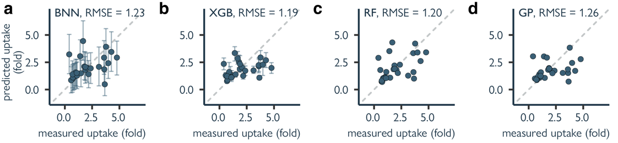 Supplementary figure S1 | Predicted vs measured uptake for different models on the initial data (cycle 0). a. Bayesian neural network. b. XGBoost. c. Random Forest. d. Gaussian Process. Error bars in a-d represent the predicted 90% confidence interval. Performance is reported as the Root Mean Square Error (RMSE) determined through 5-fold cross validation. Different machine learning models achieve similar predictive errors, while uncertainty estimates differ considerably.

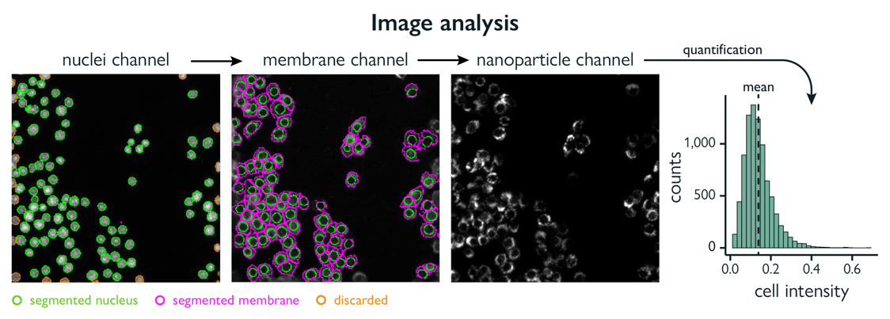
Supplementary figure S2 | Image analysis pipeline. Image analysis is done by segmentation of the nuclei, followed by membrane segmentation, and quantification of mean intensity on the nanoparticle channel. Nanoparticle intensity is measured per cell per area, which fits an expected gamma distribution, in accordance with theoretical and experimental reports²⁵.

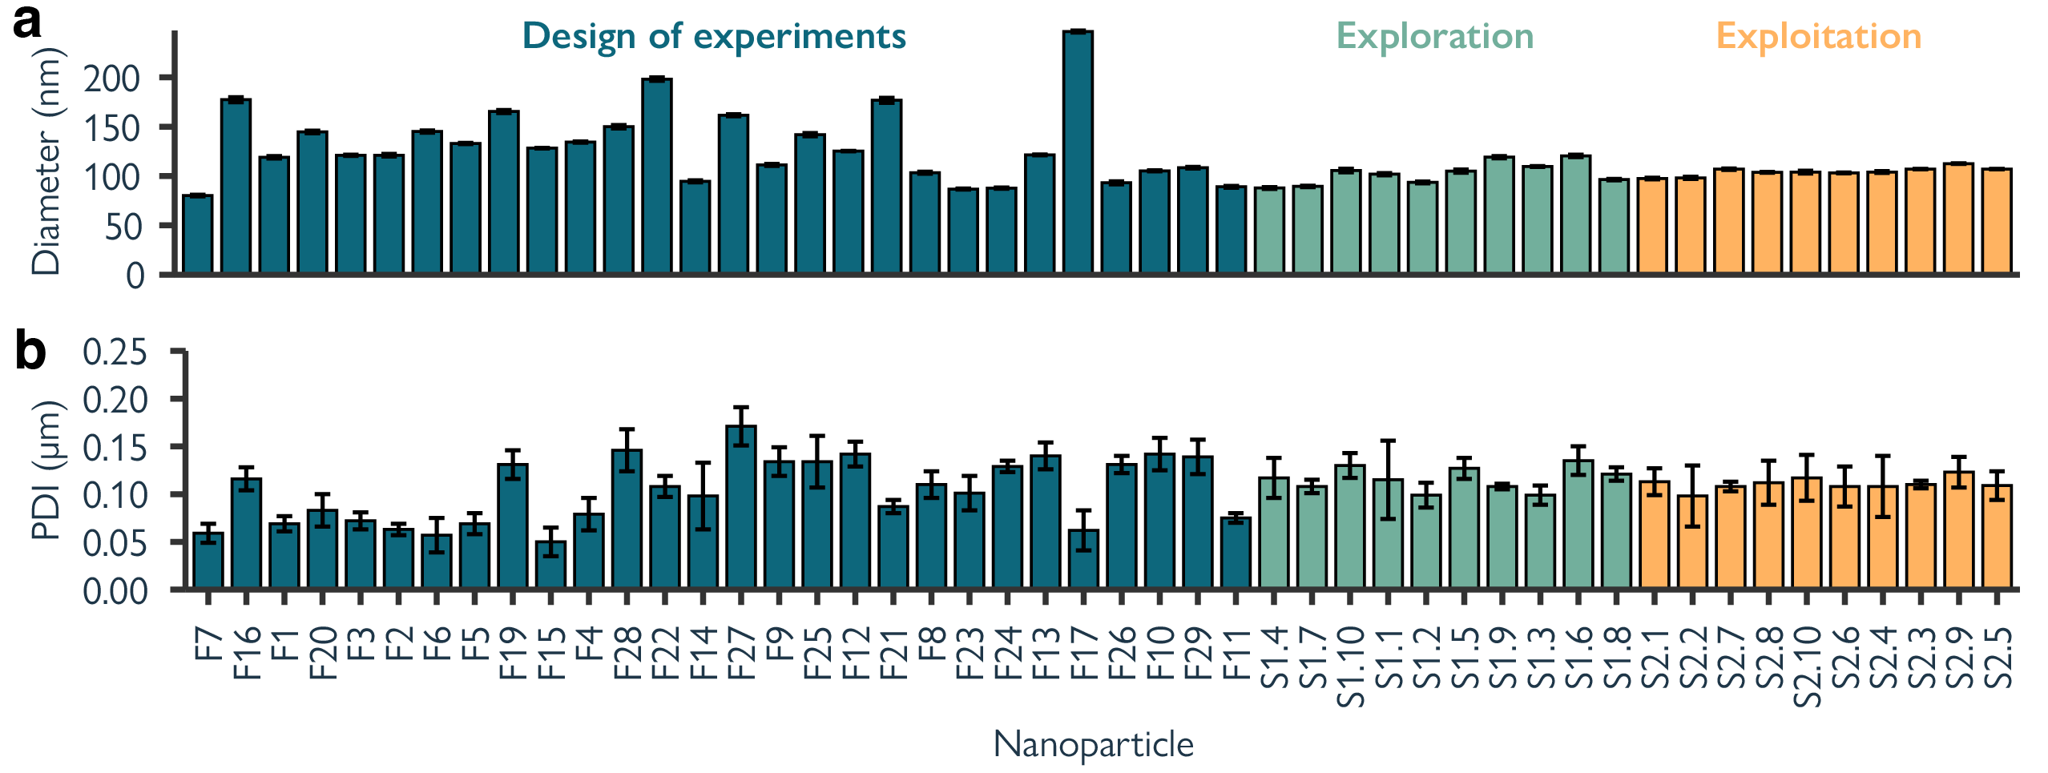Supplementary figure S3 | Size and PDI for all formulated nanoparticles.

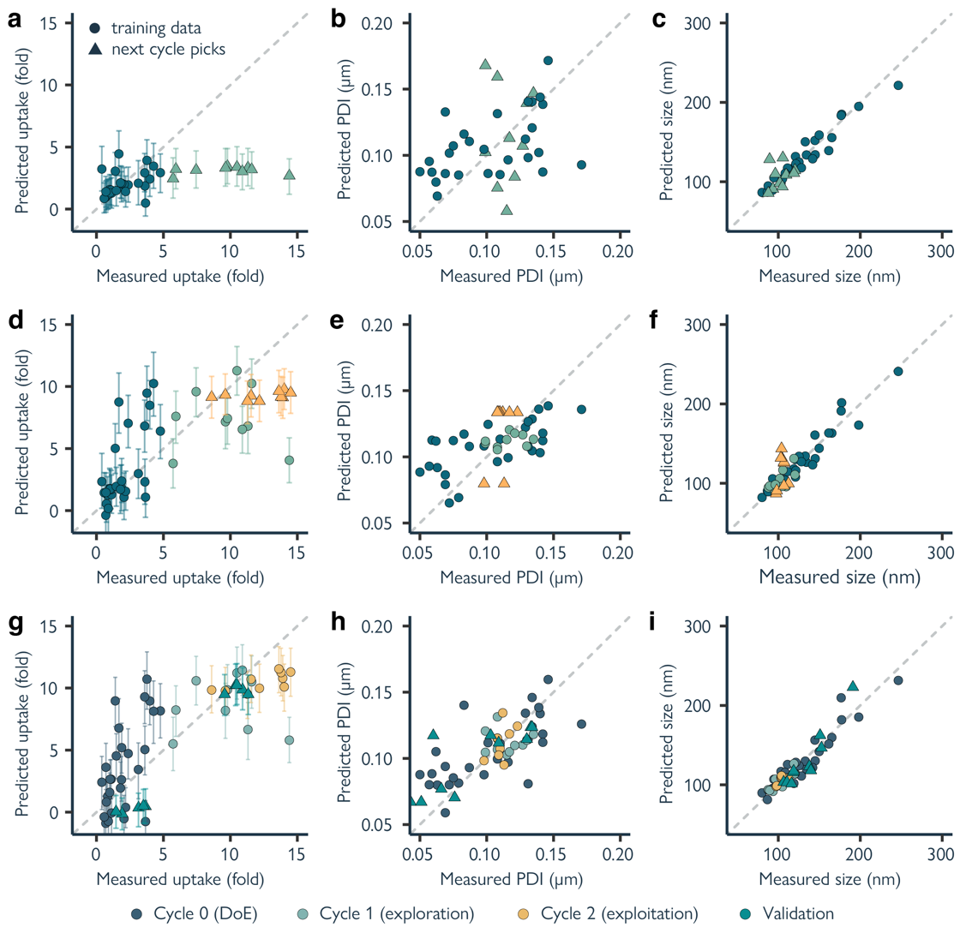
Supplementary figure S4 | Predicted vs measured uptake, PDI, and size. Every plot contains the training data used to fit the model (circles) and the nanoparticles proposed for formulation and screening (triangles). Bayesian neural networks were used for uptake predictions, while XGBoost models were used for PDI and size predictions. Error bars represent the predicted 90% confidence interval. a-c. Modelled uptake, PDI, and size using the initial dataset of 28 nanoparticles. d-e. Modeled uptake, PDI, and size using data from cycle 0 and 1. g-h. Modeled uptake, PDI, and size using data from cycle 0, 1, and 2.

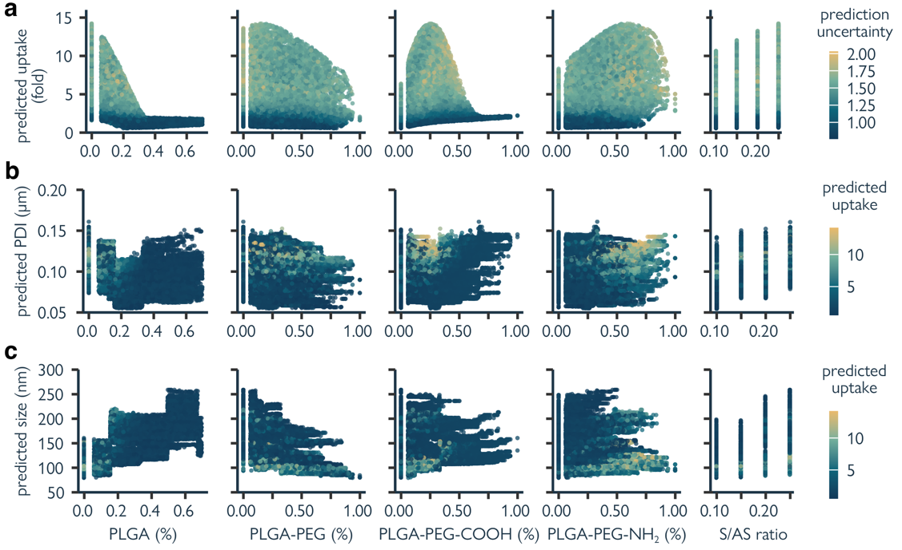
Supplementary figure S5 | Nanoparticle formulation-property relationships for uptake, PDI, and size. Every dot is a nanoparticle in the in-silico screening library. Predictions are made using the models trained on data from cycle 0, 1, and 2. a. Relationships between nanoparticle formulation variables and predicted uptake using a Bayesian neural network. Each point is a nanoparticle formulation, colored by prediction uncertainty. b-c. Relationships between nanoparticle formulation variables and predicted size/PDI using a XGBoost model. Colored by predicted uptake.

4.8 References

1. Reker, D. & Schneider, G. Active-learning strategies in computer-assisted drug discovery. Drug Discovery Today 20, 458–465 (2015).
2. Reker, D. Practical considerations for active machine learning in drug discovery. Drug Discovery Today: Technologies 32–33, 73–79 (2019).
3. Nahal, Y. et al. Human-in-the-loop active learning for goal-oriented molecule generation. J Cheminform 16, 138 (2024).
4. Pelaz, B. et al. Diverse Applications of Nanomedicine. ACS Nano 11, 2313–2381 (2017).
5. Murar, M., Albertazzi, L. & Pujals, S. Advanced Optical Imaging-Guided Nanotheranostics towards Personalized Cancer Drug Delivery. Nanomaterials (Basel) 12, 399 (2022).
6. Feng, C. et al. Emerging vaccine nanotechnology: From defense against infection to sniping cancer. Acta Pharmaceutica Sinica B 12, 2206–2223 (2022).
7. Nam, J. et al. Cancer nanomedicine for combination cancer immunotherapy. Nat Rev Mater 4, 398–414 (2019).
8. Mitchell, M. J. et al. Engineering precision nanoparticles for drug delivery. Nat Rev Drug Discov 20, 101–124 (2021).
9. Stiepel, R. T., Duggan, E., Batty, C. J. & Ainslie, K. M. Micro and nanotechnologies: The little formulations that could. Bioengineering & Translational Medicine 8, e10421 (2023).
10. Yamankurt, G. et al. Exploration of the nanomedicine-design space with high-throughput screening and machine learning. Nat Biomed Eng 3, 318–327 (2019).
11. Valencia, P. M. et al. Microfluidic Platform for Combinatorial Synthesis and Optimization of Targeted Nanoparticles for Cancer Therapy. ACS Nano 7, 10671–10680 (2013).
12. Blanco, E., Shen, H. & Ferrari, M. Principles of nanoparticle design for overcoming biological barriers to drug delivery. Nat Biotechnol 33, 941–951 (2015).
13. Poon, W., Kingston, B. R., Ouyang, B., Ngo, W. & Chan, W. C. W. A framework for designing delivery systems. Nat. Nanotechnol. 15, 819–829 (2020).
14. Mekki-Berrada, F. et al. Two-step machine learning enables optimized nanoparticle synthesis. npj Comput Mater 7, 55 (2021).
15. Abdel-Latif, K. et al. Self‐Driven Multistep Quantum Dot Synthesis Enabled by Autonomous Robotic Experimentation in Flow. Advanced Intelligent Systems 3, 2000245 (2021).
16. Voznyy, O. et al. Machine Learning Accelerates Discovery of Optimal Colloidal Quantum Dot Synthesis. ACS Nano 13, 11122–11128 (2019).
17. Bao, Z. et al. Revolutionizing drug formulation development: The increasing impact of machine learning. Advanced Drug Delivery Reviews 202, 115108 (2023).
18. Reker, D. et al. Computationally guided high-throughput design of self-assembling drug nanoparticles. Nat. Nanotechnol. 16, 725–733 (2021).
19. Shi, Y. et al. A machine learning liver-on-a-chip system for safer drug formulation. Preprint at https://doi.org/10.1101/2022.09.05.506668 (2022).
20. Valencia, P. M., Farokhzad, O. C., Karnik, R. & Langer, R. Microfluidic technologies for accelerating the clinical translation of nanoparticles. Nat Nanotechnol 7, 623–629 (2012).
21. Shepherd, S. J., Issadore, D. & Mitchell, M. J. Microfluidic formulation of nanoparticles for biomedical applications. Biomaterials 274, 120826 (2021).
22. Haase, R. et al. A Hitchhiker’s guide through the bio-image analysis software universe. FEBS Letters 596, 2472–2485 (2022).
23. Mattiazzi Usaj, M. et al. High-Content Screening for Quantitative Cell Biology. Trends in Cell Biology 26, 598–611 (2016).
24. Brayden, D. J., Cryan, S.-A., Dawson, K. A., O’Brien, P. J. & Simpson, J. C. High-content analysis for drug delivery and nanoparticle applications. Drug Discov Today 20, 942–957 (2015).
25. Yang, B. et al. Following nanoparticle uptake by cells using high-throughput microscopy and the deep-learning based cell identification algorithm Cellpose. Frontiers in Nanotechnology 5, (2023).
26. Cutrona, M. B. & Simpson, J. C. A High-Throughput Automated Confocal Microscopy Platform for Quantitative Phenotyping of Nanoparticle Uptake and Transport in Spheroids. Small 15, 1902033 (2019).
27. Kelly, S., Byrne, M. H., Quinn, S. J. & Simpson, J. C. Multiparametric nanoparticle-induced toxicity readouts with single cell resolution in HepG2 multicellular tumour spheroids. Nanoscale 13, 17615–17628 (2021).
28. Chen, X. & Lv, H. Intelligent control of nanoparticle synthesis on microfluidic chips with machine learning. NPG Asia Mater 14, 69 (2022).
29. Tao, H. et al. Nanoparticle synthesis assisted by machine learning. Nat Rev Mater 6, 701–716 (2021).
30. Krause, A., Singh, A. & Guestrin, C. Near-optimal sensor placements in Gaussian processes: Theory, efficient algorithms and empirical studies. Journal of Machine Learning Research 9, (2008).
31. Liu, Y. et al. Formulation of Nanoparticles Using Mixing-Induced Nanoprecipitation for Drug Delivery. Ind. Eng. Chem. Res. 59, 4134–4149 (2020).
32. Karnik, R. et al. Microfluidic Platform for Controlled Synthesis of Polymeric Nanoparticles. Nano Lett. 8, 2906–2912 (2008).
33. Mares, A. G., Pacassoni, G., Marti, J. S., Pujals, S. & Albertazzi, L. Formulation of tunable size PLGA-PEG nanoparticles for drug delivery using microfluidic technology. PLOS ONE 16, e0251821 (2021).
34. McQuin, C. et al. CellProfiler 3.0: Next-generation image processing for biology. PLOS Biology 16, e2005970 (2018).
35. Alijagic, A. et al. A Novel Nanosafety Approach Using Cell Painting, Metabolomics, and Lipidomics Captures the Cellular and Molecular Phenotypes Induced by the Unintentionally Formed Metal-Based (Nano)Particles. Cells 12, 281 (2023).
36. Rui, Y. et al. High-throughput and high-content bioassay enables tuning of polyester nanoparticles for cellular uptake, endosomal escape, and systemic in vivo delivery of mRNA. Sci Adv 8, (2022).
37. Settles, B. Active Learning Literature Survey. https://minds.wisconsin.edu/handle/1793/60660 (2009).
38. Graves, A. Practical Variational Inference for Neural Networks. in Advances in Neural Information Processing Systems (eds. Shawe-Taylor, J., Zemel, R., Bartlett, P., Pereira, F. & Weinberger, K. Q.) vol. 24 (Curran Associates, Inc., 2011).
39. Ovadia, Y. et al. Can you trust your model’ s uncertainty? Evaluating predictive uncertainty under dataset shift. in Advances in Neural Information Processing Systems vol. 32 (Curran Associates, Inc., 2019).
40. Wu, A. et al. Deterministic variational inference for robust Bayesian neural networks. (2019).
41. Meyer, T. A., Ramirez, C., Tamasi, M. J. & Gormley, A. J. A User’s Guide to Machine Learning for Polymeric Biomaterials. ACS Polym. Au 3, 141–157 (2023).
42. Bao, Z. et al. Data-driven development of an oral lipid-based nanoparticle formulation of a hydrophobic drug. Drug Deliv. and Transl. Res. (2023) doi:10.1007/s13346-023-01491-9.
43. Rabanel, J.-M. et al. Nanoparticle heterogeneity: an emerging structural parameter influencing particle fate in biological media? Nanoscale 11, 383–406 (2019).
44. Jospin, L. V., Laga, H., Boussaid, F., Buntine, W. & Bennamoun, M. Hands-On Bayesian Neural Networks—A Tutorial for Deep Learning Users. IEEE Comput. Intell. Mag. 17, 29–48 (2022).
45. Kingma, D. P. & Ba, J. Adam: A Method for Stochastic Optimization. (2014) doi:10.48550/ARXIV.1412.6980.
46. Bishop, C. Pattern Recognition and Machine Learning. (Springer, 2006).
47. Chen, T. & Guestrin, C. XGBoost: A Scalable Tree Boosting System. in Proceedings of the 22nd ACM SIGKDD International Conference on Knowledge Discovery and Data Mining 785–794 (ACM, San Francisco California USA, 2016). doi:10.1145/2939672.2939785.
48. Zhdanov, F. Diverse mini-batch Active Learning. (2019) doi:10.48550/ARXIV.1901.05954.

